Main goal: activate the BLE stack to use the BLE service (e.g. battery service)

1)initialize the BLE stack:

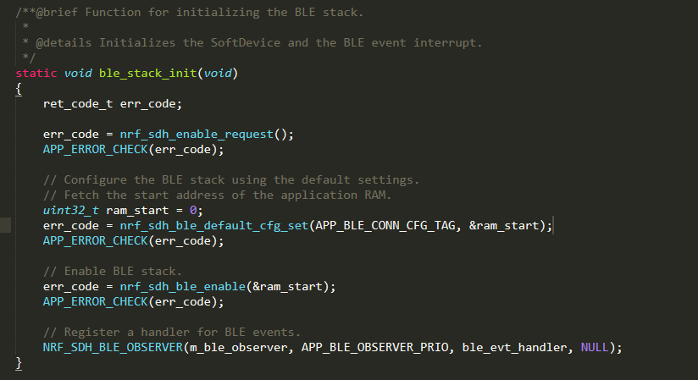

Pay attention to the observer registering; it calls out the BLE event handler.

2)ble_evt_handler, handling the connection state between BLE stack and GAP and GATT?

When connected, indicated it is connected by (LED)?

Disconnect when some situation happens

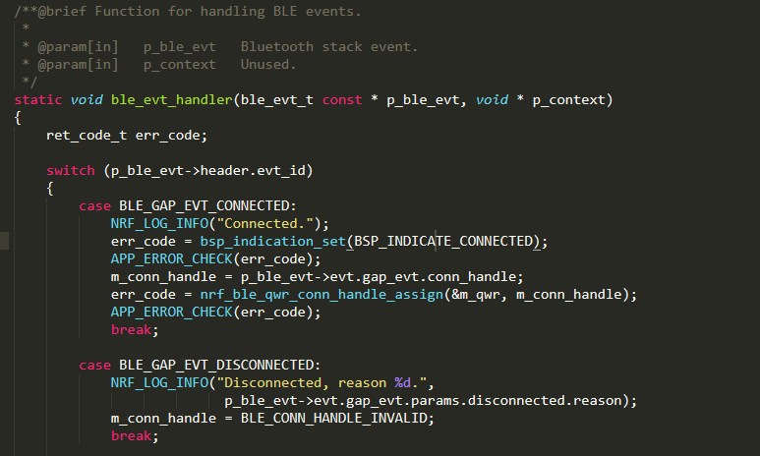

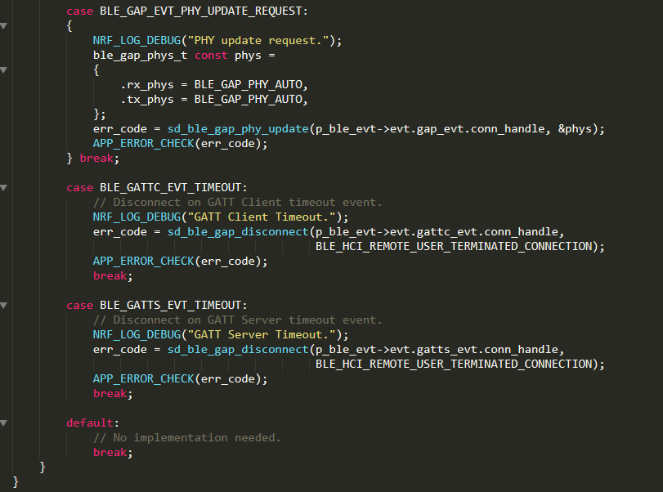

m_conn_handle: for indication



Note: some specific parameter should also be set in GAP and GATT module to apply the heart rate service.

The process of the whole example:

